**Experiment-7**

Create a simple cloud software application for Students Attendance System using any Cloud Service Provider to demonstrate SaaS include the necessary fields such as name of the students, course, present , Absent, course attendance, OD request, grade, attendance percentage, etc.

**Implementation:**

**STEP 01:**

Open a Zoho web application and click a Create a New application and Create a New Component And select a Component Type as Form Type.

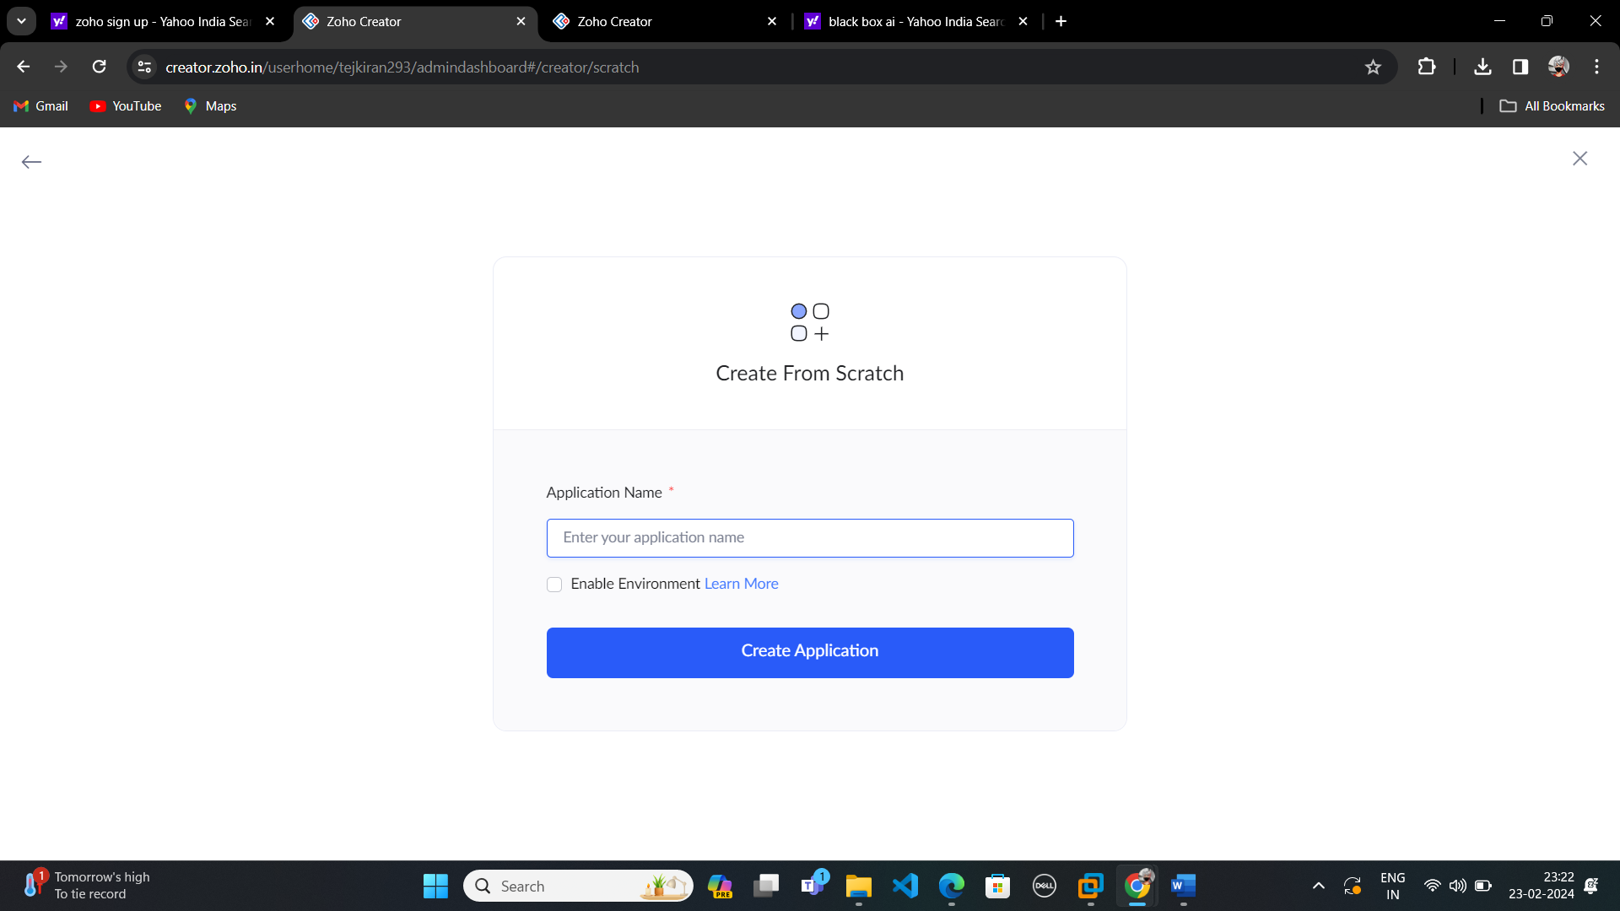

**STEP:02**

Start To a Create a Form from Scratch

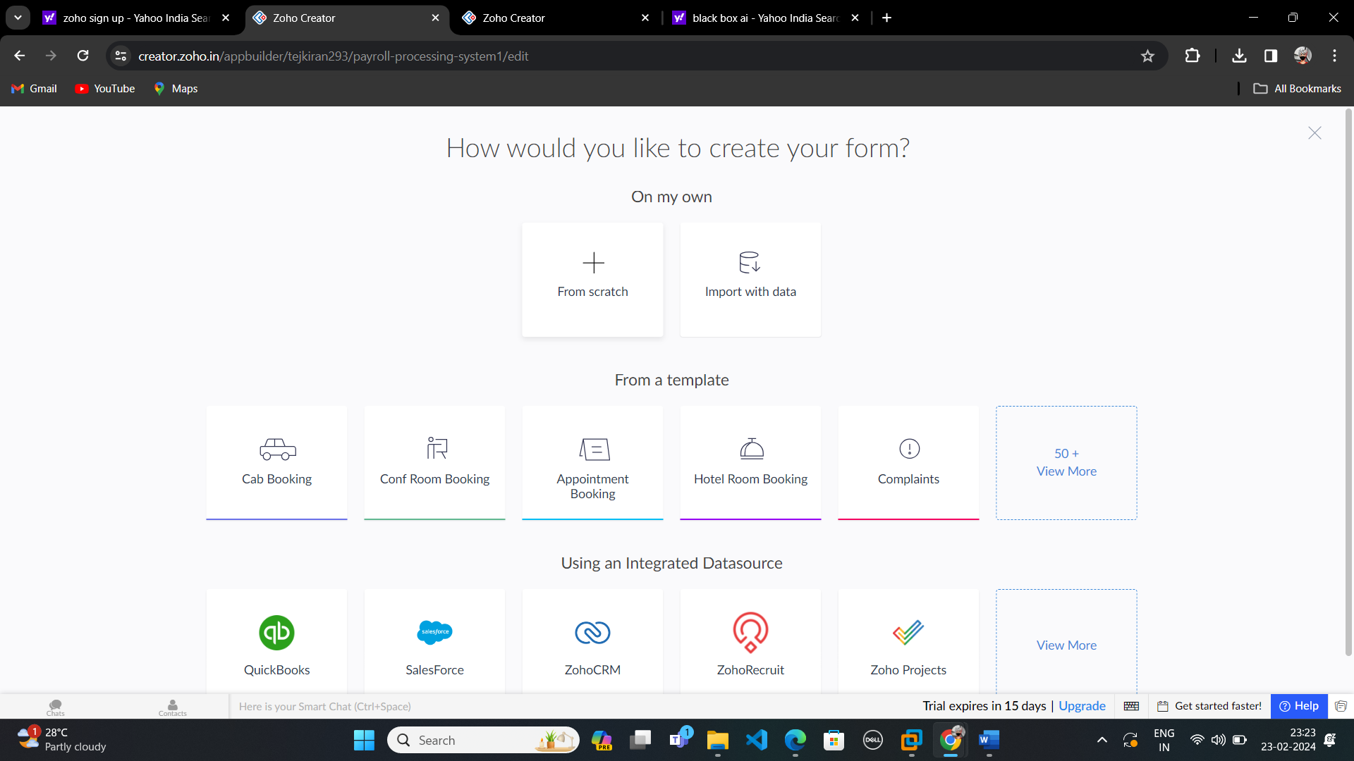

**STEP 03:**

To Give a Name For Your Form and click a Button Create From Scratch

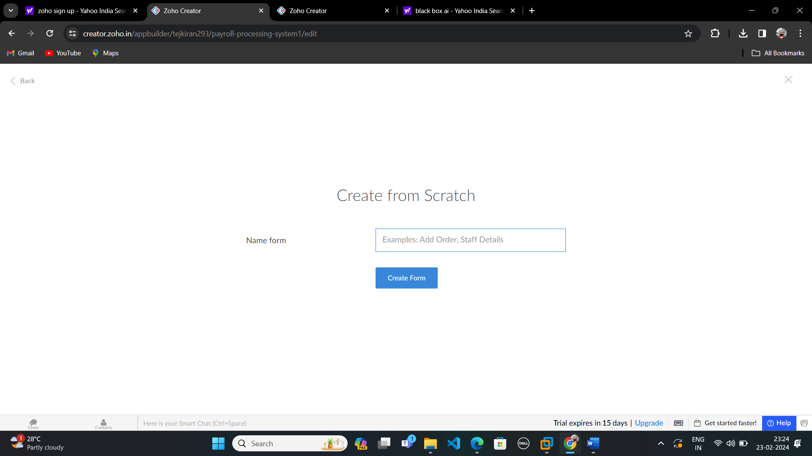

**STEP 04:**

Create Log in form and edit the form.

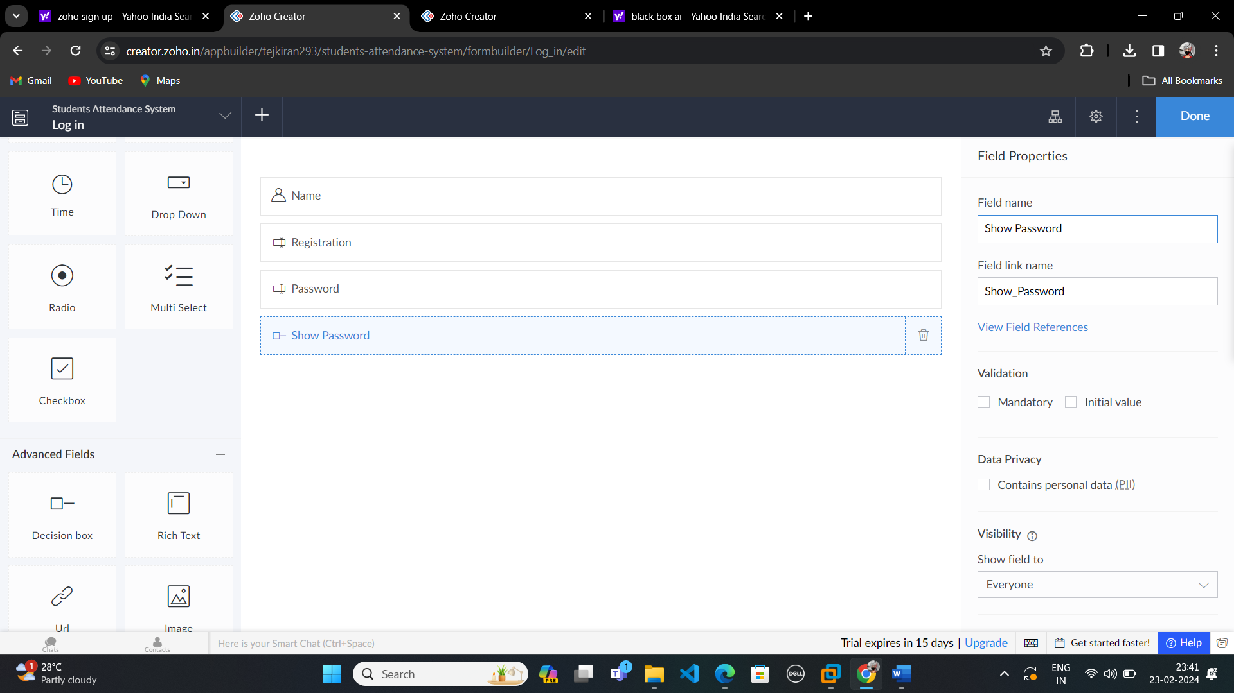

**Step-05:**

After Finishing that,Create another form for your application by clicking a Add icon and Edit that form.

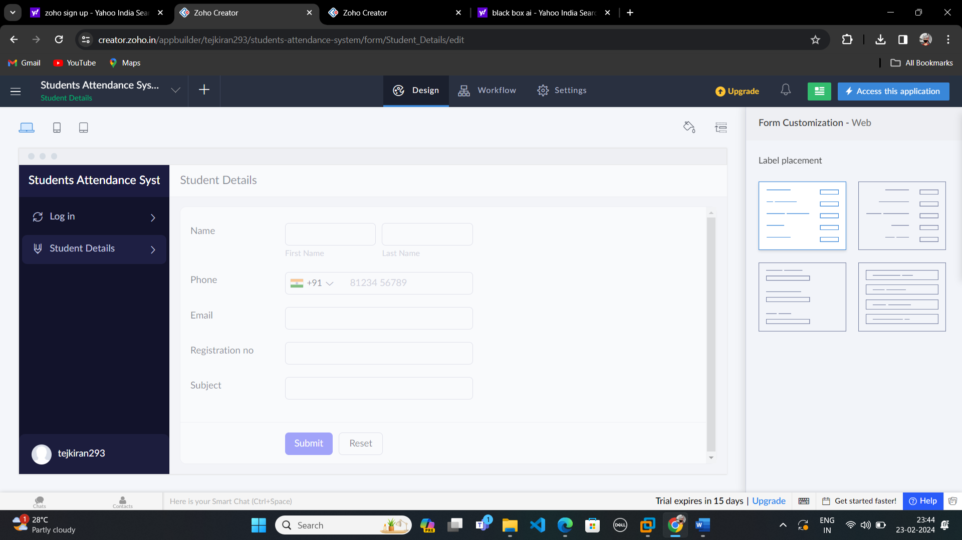

**Step-06:**

After creating that create another form and name it as Attendence Details.

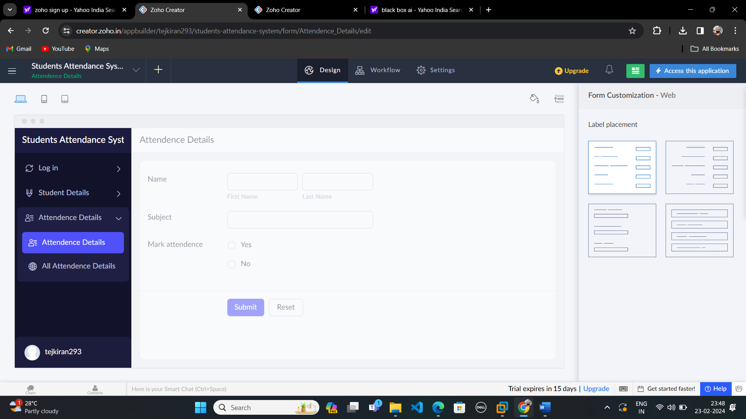

**STEP-07:**

Create Report form.

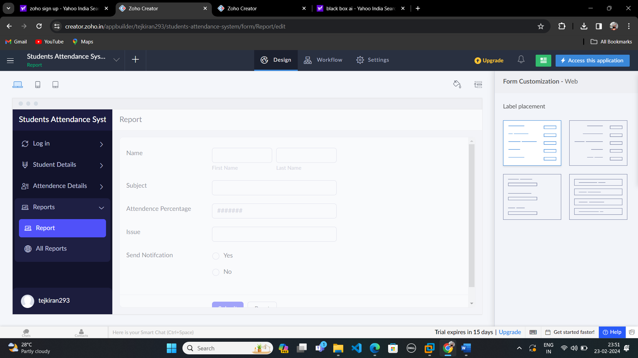

**Step-08:**

After creating report form tap Access this Application.

